Partial / residual correlation: EURUSD and NZDUSD
Method 07 / daily log returns / leave-currency-out USD factor / Alpari D1 full available history

Study setup
Logical pair: EURUSD , NZDUSD
Broker symbols: EURUSD_i , NZDUSD_i
Snapshot: 2026-11-03_majors_alpari_D1
Timeframe: D1
Matched return window: 1999-01-05 to 2026-11-02 (UTC bar dates)
Matched return count n: 7148
Dropped unfinished last bar dated 2026-11-03 UTC after a tick-volume check against the prior complete day.
USD-strength sign rule: minus log return when USD is the quote (EURUSD, GBPUSD, AUDUSD, NZDUSD); plus log return when USD is the base (USDJPY, USDCHF, USDCAD). EURGBP is never a constituent.
Control z constituents (5): GBPUSD, AUDUSD, USDJPY, USDCHF, USDCAD
z_t = equal-weight mean of those USD-strength returns on the same day
Complete matched rows (Excel): EURUSD-NZDUSD_Partial_D1.xlsx
Complete matched rows (HTML table): EURUSD-NZDUSD_Partial_D1_data.html

Method carried forward
Partial / residual correlation regresses each matched daily log return of close, ln(close_t / close_t-1), on the same leave-currency-out USD strength factor z, then takes Pearson correlation of the two residual series. Quotes are not inverted. z is the equal-weight mean of USD-strength returns from other majors that do not share a non-USD currency with either leg; EURGBP is never a constituent. USD-strength is minus the log return when USD is the quote (EURUSD, GBPUSD, AUDUSD, NZDUSD) and plus the log return when USD is the base (USDJPY, USDCHF, USDCAD). OLS uses an intercept on each leg. rho_partial is symmetric under swap of the two symbols. It describes leftover linear co-movement after removing linear z; it is not a cause, not a lead, and not a trading signal. Daily rows are not independent and residuals are estimated, so the two-sided p-value and Fisher interval are secondary. Same-sample raw Pearson r is a side check only.

Regression on z
leg | intercept_a_or_c | slope_b_or_d | R2
EURUSD | -1.067e-05 | -1.0453453 | 0.61197631
NZDUSD | 8.76e-06 | -1.27496 | 0.5241808

Results
rho_partial: -0.035903
Two-sided p-value: 0.00239826
Approximate 95% Fisher interval: [-0.059037, -0.012731]
Same-sample raw Pearson r: 0.550953
rho_partial minus r: -0.586856

Conclusion
Over 7148 matched daily rows for EURUSD and NZDUSD after removing a leave-currency-out USD factor built from 5 constituents, rho_partial is -0.0359 (negative, weak residual linear link in this sample). Approximate 95% Fisher interval: [-0.0590, -0.0127]. Same-sample raw Pearson r is 0.5510 (partial minus r = -0.5869). Leg R-squared on z: EURUSD=0.6120, NZDUSD=0.5242. Two-sided p under the usual independent-pairs model is 0.002398; residuals are estimated and daily FX rows are linked, so treat p as secondary. This does not establish cause, lead-lag, or a lasting trading rule.

Charts
Daily closes
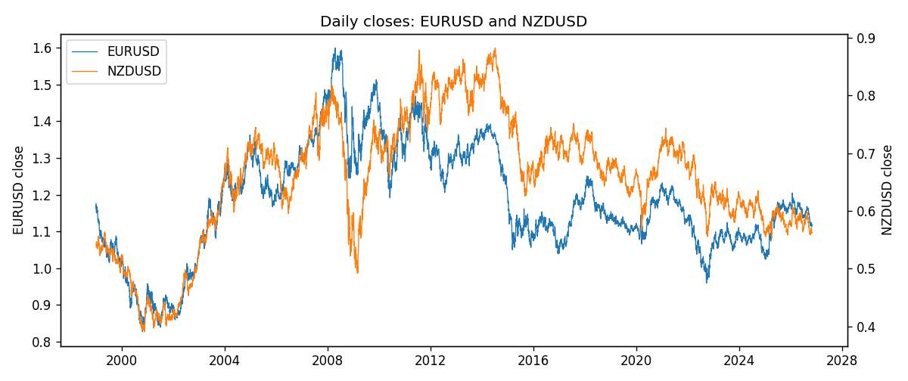
Log returns and control z
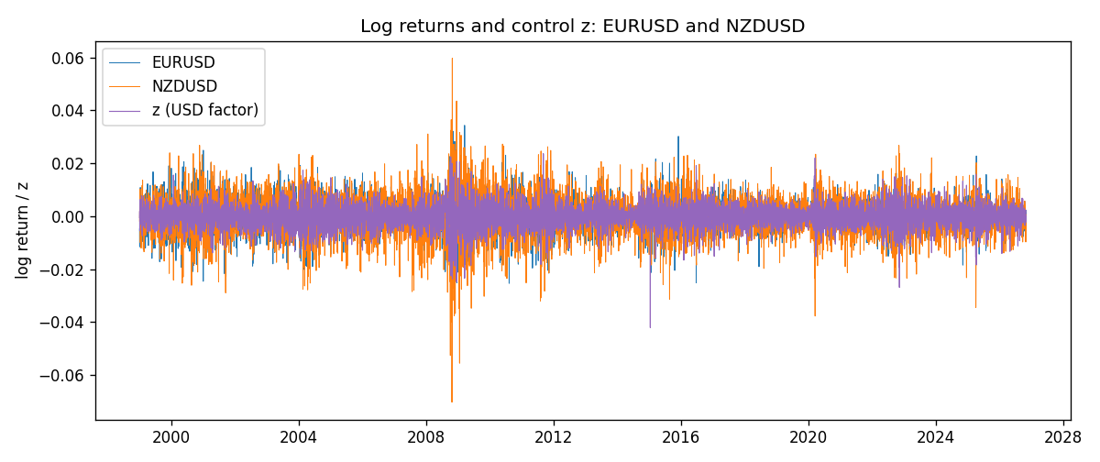
Residual scatter e_x vs e_y
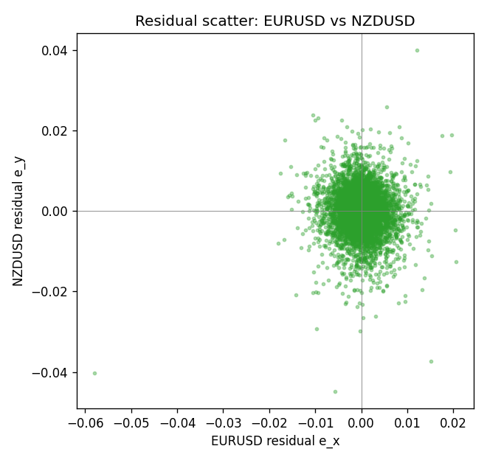

Data report
Every matched row that entered the partial correlation is stored in the sibling Excel workbook named EURUSD-NZDUSD_Partial_D1.xlsx. That file is the complete data archive for redrawing charts. Embedding all rows as a Word table is impractical at this length; the Word file holds the column list, column summaries, and the first and last 15 matched rows.
Columns: time, EURUSD_open, NZDUSD_open, EURUSD_high, NZDUSD_high, EURUSD_low, NZDUSD_low, EURUSD_close, NZDUSD_close, EURUSD_tick_volume, NZDUSD_tick_volume, EURUSD_spread, NZDUSD_spread, EURUSD_real_volume, NZDUSD_real_volume, EURUSD_log_return, NZDUSD_log_return, usd_strength_GBPUSD, usd_strength_AUDUSD, usd_strength_USDJPY, usd_strength_USDCHF, usd_strength_USDCAD, z, EURUSD_fitted, NZDUSD_fitted, EURUSD_resid, NZDUSD_resid
Column summaries (matched calculation rows)
column | count | mean | std | min | 25% | 50% | 75% | max
EURUSD_open | 7148 | 1.1816879 | 0.15074041 | 0.8272 | 1.0863875 | 1.16609 | 1.2942 | 1.5995
NZDUSD_open | 7148 | 0.65680048 | 0.1080291 | 0.3913 | 0.5917475 | 0.668695 | 0.72504 | 0.88218
EURUSD_high | 7148 | 1.1868219 | 0.15134312 | 0.8326 | 1.0904675 | 1.17121 | 1.29957 | 1.6038
NZDUSD_high | 7148 | 0.66072183 | 0.10852081 | 0.3961 | 0.595065 | 0.67222 | 0.729525 | 0.88421
EURUSD_low | 7148 | 1.1766784 | 0.15005373 | 0.8227 | 1.0822025 | 1.162475 | 1.2886225 | 1.5865
NZDUSD_low | 7148 | 0.65311385 | 0.10762321 | 0.3897 | 0.588355 | 0.66451 | 0.72113 | 0.87988
EURUSD_close | 7148 | 1.1817317 | 0.15070664 | 0.8267 | 1.0862225 | 1.16602 | 1.2942 | 1.5997
NZDUSD_close | 7148 | 0.65687963 | 0.10802405 | 0.3907 | 0.592165 | 0.66876 | 0.72518 | 0.8822
EURUSD_tick_volume | 7148 | 103711.54 | 173856.26 | 469 | 9484.75 | 52998 | 99801.75 | 1471626
NZDUSD_tick_volume | 7148 | 69051.458 | 123370.73 | 17 | 5742 | 34119 | 58667.5 | 1127682
EURUSD_spread | 7148 | 19.246223 | 16.509774 | 0 | 8 | 12 | 20 | 50
NZDUSD_spread | 7148 | 30.128428 | 25.588679 | 0 | 9 | 17 | 40 | 80
EURUSD_real_volume | 7148 | 4.0536992e+10 | 1.6733469e+11 | 0 | 0 | 0 | 0 | 3.6149665e+12
NZDUSD_real_volume | 7148 | 1.678526e+10 | 8.5194876e+10 | 0 | 0 | 0 | 0 | 2.705649e+12
EURUSD_log_return | 7148 | -2.16e-06 | 0.0058013 | -0.03123819 | -0.00324218 | 0 | 0.00325609 | 0.03433183
NZDUSD_log_return | 7148 | 1.914e-05 | 0.00764519 | -0.07027433 | -0.00424201 | 0.00023666 | 0.004586 | 0.05966839
usd_strength_GBPUSD | 7148 | 1.992e-05 | 0.00564699 | -0.03112653 | -0.00318167 | -3.426e-05 | 0.0031217 | 0.08388241
usd_strength_AUDUSD | 7148 | -3.157e-05 | 0.00755018 | -0.0806166 | -0.00415111 | -0.00029168 | 0.00385014 | 0.08602525
usd_strength_USDJPY | 7148 | 5.267e-05 | 0.00620906 | -0.03908203 | -0.00319392 | 0.00012736 | 0.00340928 | 0.05184024
usd_strength_USDCHF | 7148 | -6.945e-05 | 0.0065937 | -0.19545699 | -0.00334697 | 8.15e-05 | 0.00331954 | 0.09051364
usd_strength_USDCAD | 7148 | -1.226e-05 | 0.00514518 | -0.03859748 | -0.00283513 | 4.873e-05 | 0.00272781 | 0.03436319
z | 7148 | -8.14e-06 | 0.00434143 | -0.0420736 | -0.00247042 | 4.261e-05 | 0.00245004 | 0.02363089
EURUSD_fitted | 7148 | -2.16e-06 | 0.00453829 | -0.02471311 | -0.00257181 | -5.522e-05 | 0.00257177 | 0.04397077
NZDUSD_fitted | 7148 | 1.914e-05 | 0.00553515 | -0.03011968 | -0.00311494 | -4.556e-05 | 0.00315845 | 0.05365093
EURUSD_resid | 7148 | 0 | 0.00361372 | -0.05791221 | -0.00192375 | -1.305e-05 | 0.00188772 | 0.02052718
NZDUSD_resid | 7148 | 0 | 0.00527363 | -0.04481304 | -0.00277398 | 0.00015486 | 0.00291409 | 0.04006882
First 15 matched rows (selected columns)
time | EURUSD_close | NZDUSD_close | EURUSD_log_return | NZDUSD_log_return | z | EURUSD_fitted | NZDUSD_fitted | EURUSD_resid | NZDUSD_resid
1999-01-05 | 1.1758 | 0.5372 | -0.0048360507 | -0.0018597736 | -0.0005334128 | 0.00054692767 | 0.00068884397 | -0.0053829783 | -0.0025486176
1999-01-06 | 1.1623 | 0.5383 | -0.011547966 | 0.0020455609 | 0.0019218325 | -0.0020196513 | -0.0024414956 | -0.009528315 | 0.0044870565
1999-01-07 | 1.1712 | 0.5417 | 0.0076280636 | 0.0062963171 | -0.0054932148 | 0.0057316332 | 0.0070123933 | 0.0018964303 | -0.00071607618
1999-01-08 | 1.1585 | 0.5414 | -0.010902799 | -0.00055396548 | 0.0019598038 | -0.0020593445 | -0.0024899075 | -0.0088434548 | 0.001935942
1999-01-11 | 1.1503 | 0.547 | -0.007103287 | 0.010290425 | -0.0031898257 | 0.0033237963 | 0.0040756643 | -0.010427083 | 0.006214761
1999-01-12 | 1.1555 | 0.5441 | 0.0045103728 | -0.0053157489 | 0.0063394849 | -0.0066376234 | -0.0080738258 | 0.011147996 | 0.0027580769
1999-01-13 | 1.1681 | 0.5387 | 0.010845346 | -0.0099742238 | -0.0013646384 | 0.0014158454 | 0.0017486233 | 0.0094295011 | -0.011722847
1999-01-14 | 1.1681 | 0.5386 | 0 | -0.00018564931 | 0.0010542537 | -0.001112732 | -0.0013353673 | 0.001112732 | 0.001149718
1999-01-15 | 1.1563 | 0.5382 | -0.010153245 | -0.00074294208 | 0.0024837545 | -0.0026070539 | -0.0031579237 | -0.0075461912 | 0.0024149816
1999-01-18 | 1.1605 | 0.5372 | 0.0036256946 | -0.0018597736 | -0.00085435159 | 0.00088241951 | 0.0010980281 | 0.0027432751 | -0.0029578017
1999-01-19 | 1.1603 | 0.5382 | -0.00017235436 | 0.0018597736 | -0.0024085979 | 0.0025071436 | 0.0030796301 | -0.0026794979 | -0.0012198564
1999-01-20 | 1.1566 | 0.5404 | -0.0031939256 | 0.0040793678 | -9.4418083e-05 | 8.8026619e-05 | 0.00012914325 | -0.0032819522 | 0.0039502245
1999-01-21 | 1.1601 | 0.5426 | 0.0030215416 | 0.0040627941 | -0.00071441753 | 0.00073614011 | 0.00091961777 | 0.0022854014 | 0.0031431764
1999-01-22 | 1.1587 | 0.5361 | -0.0012075213 | -0.012051689 | 0.0036354091 | -0.0038109306 | -0.0046262373 | 0.0026034093 | -0.007425452
1999-01-25 | 1.1552 | 0.5342 | -0.0030251979 | -0.0035504102 | -0.0002592821 | 0.00026036644 | 0.00033933829 | -0.0032855643 | -0.0038897484
Last 15 matched rows (selected columns)
time | EURUSD_close | NZDUSD_close | EURUSD_log_return | NZDUSD_log_return | z | EURUSD_fitted | NZDUSD_fitted | EURUSD_resid | NZDUSD_resid
2026-10-13 | 1.11965 | 0.56127 | 0.0037402957 | 0.0047326165 | -0.0032345226 | 0.00337052 | 0.004132651 | 0.00036977571 | 0.00059996552
2026-10-14 | 1.11545 | 0.55918 | -0.0037582255 | -0.0037306483 | 0.0021937794 | -0.0023039298 | -0.0027882171 | -0.0014542957 | -0.00094243117
2026-10-15 | 1.12172 | 0.56185 | 0.0056053107 | 0.0047634855 | -0.0028602099 | 0.002979234 | 0.0036554172 | 0.0026260767 | 0.0011080682
2026-10-16 | 1.12371 | 0.56509 | 0.0017724895 | 0.0057501001 | -0.0029169793 | 0.0030385776 | 0.003727796 | -0.0012660881 | 0.0020223042
2026-10-19 | 1.12086 | 0.56616 | -0.0025394633 | 0.0018917133 | 0.00038207235 | -0.0004100704 | -0.000478363 | -0.0021293929 | 0.0023700763
2026-10-20 | 1.12354 | 0.56827 | 0.0023881672 | 0.0037199341 | -0.0035287549 | 0.0036780943 | 0.0045077854 | -0.0012899271 | -0.00078785125
2026-10-21 | 1.12318 | 0.57003 | -0.00032046717 | 0.0030923331 | -0.0012860597 | 0.0013337035 | 0.0016484386 | -0.0016541707 | 0.0014438945
2026-10-22 | 1.12139 | 0.56815 | -0.0015949606 | -0.0033035227 | -0.0029970674 | 0.0031222973 | 0.003829905 | -0.0047172579 | -0.0071334277
2026-10-23 | 1.11989 | 0.56991 | -0.001338521 | 0.0030929853 | 0.0011540005 | -0.0012170018 | -0.0014625405 | -0.00012151926 | 0.0045555257
2026-10-26 | 1.11735 | 0.56826 | -0.0022706559 | -0.0028993932 | 0.0023318252 | -0.0024482353 | -0.00296422 | 0.00017757945 | 6.4826829e-05
2026-10-27 | 1.11272 | 0.56811 | -0.004152342 | -0.00026399852 | 0.0017222032 | -0.0018109698 | -0.0021869762 | -0.0023413722 | 0.0019229777
2026-10-28 | 1.1152 | 0.56261 | 0.0022262927 | -0.0097283914 | -0.0022955338 | 0.0023889525 | 0.0029354777 | -0.00016265975 | -0.012663869
2026-10-29 | 1.11772 | 0.56296 | 0.0022571351 | 0.00062190714 | -0.00097189173 | 0.0010052895 | 0.0012478871 | 0.0012518456 | -0.00062597994
2026-10-30 | 1.11644 | 0.56307 | -0.0011458446 | 0.00019537668 | -0.00074577484 | 0.00076891932 | 0.00095959708 | -0.001914764 | -0.00076422041
2026-11-02 | 1.11881 | 0.56161 | 0.002120569 | -0.0025962955 | -1.3111715e-05 | 3.0333926e-06 | 2.5480884e-05 | 0.0021175356 | -0.0026217764

